Emergency Action Plan
For Glenelg High School
Athletics Program

In case of an emergency, personnel responsibilities, locations of emergency equipment, and other emergency information such as 911 call instructions, addresses/directions to the venue, and a chain of command with important phone numbers have been listed here.
Table of Contents
Table of Contents
Personnel Involved in Development 3
Documentation of Recent Changes 4
Introduction 5
Staff Education 9
Emergency Telephone Numbers 10
Emergency Situation Contact Tree 11
Emergency Equipment Locations 12
Glenelg High School AED Location 13
General Action Plan……………………………………………………………………………………………………………………………………14
Emergency Action Procedures……………………………………………………………………………………………………………………………………15
Gymnasium……………………………………………………………………………………………………………………………………………………………15
Stadium and Tennis Courts…………………………………………………………………………………………………………………………………….16
Baseball Stadium……………………………………………………………………………………………………………………………………………………17
Softball and Track & Field Fields…………………………………………………………………………………………………………………………….18
Bermuda Field 19
Football and Lacrosse Practice Field……………………………………………………………………………………………………………………….20
Severe Weather Policy……………………………………………………………………………………………………………………………………………….21
Heat Acclimation Policy……………………………………………………………………………………………………………………………………………..22
Thunder and Lightning Policy…………………………………………………………………………………………………………………………………….25
Care of Emergent Injuries………………………………………………………………………………………………………………………………………….27
AED Use…………………………………………………………………………………………………………………………………………………………………….36
Rehearsal Strategy 40
Documentation of Seasonal Coaches Educational Meeting 41
Approval and Verification Page: 42

Personnel Involved in Development
The following individuals were involved with the creation of this Emergency Action Plan:
Daniel Sageman, AAM
Allison Hammond, AT
Carolyn Hayden, AT

Documentation of Recent Changes
As changes to the EAP are made, please list the change, page affected and date that the change was made.
Specific Changes Made | Page(s) Affected | Date

EMERGENCY ACTION PLAN FOR ATHLETICS
OVERVIEW

Introduction
Emergency situations may arise at any time during athletic events. Expedient action must be taken in order to provide the best possible care to the student athlete. The development and implementation of an emergency action plan will help ensure that the best care will be provided.
As emergencies may occur at any time and during any activity, all school activities personnel must be prepared. Athletic organizations have a duty to develop an emergency action plan that may be implemented immediately when necessary and provide appropriate standards of emergency care to all sports participants. This preparation involves formulation of an emergency action plan, proper coverage of events, maintenance of appropriate emergency equipment and supplies, utilization of appropriate emergency medical personnel, and continuing education in the area of emergency medicine and planning. Through careful pre-participation physical screenings, adequate medical coverage, safe practice and training techniques and other safety avenues, some potential emergencies may be averted. However, accidents and injuries are inherent with sports participation, and proper preparation on the part of the sports medicine team should enable each emergency situation to be managed appropriately and efficiently.
Components of an Emergency Action Plan
- Emergency Personnel
- Emergency Communication
- Emergency Equipment
- Roles of First Responder
- Venue Directions with a Map
- Emergency Action Plan Checklist for Non-Medical Emergencies
Emergency Personnel
The first responder in an emergency situation during an athletic practice or competition is typically a member of the sports medicine staff, such as a certified athletic trainer. However, the first responder may also be a coach or another member of the school personnel.
Certification in cardiopulmonary resuscitation (CPR), first aid, automated external defibrillator (AED), emergency action plan review, and prevention of disease transmission, and emergency plan review is required for all athletics personnel associated with practices, competitions, skills instructions, and strength and conditioning [including: athletic director, school nurse, certified athletic trainer, all coaches, etc.]. Copies of training certificates and/or cards should be maintained with the athletic director. All coaches are required to have CPR, Care and Prevention of Injury, AED, and emergency plan review.
The emergency team may consist of physicians, emergency medical technicians, certified athletic trainers, athletic training students, coaches, managers, and possibly even bystanders. Roles of these individuals will vary depending on different factors such as team size, athletic venue, personnel present, etc.
The four basic roles within the emergency team are:
- Establish scene safety and immediate care of the athlete:
  - This should be provided by the most qualified individual on the medical team (the first individual in the chain of command).
- Activation of Emergency Medical Services:
  - This may be necessary in situations where emergency transportation is not already present at the sporting event. Time is the most critical factor and this may be done by anyone on the team.
- Equipment Retrieval:
  - May be done by anyone on the emergency team who is familiar with the types and locations of the specific equipment needed.
- Direction of EMS to the scene:
  - One of the members of the team should be in charge of meeting the emergency personnel as they arrive at the site. This person should have keys to locked gates/doors.

Activating Emergency Medical Services
Call 9-1-1
Provide information
- Name, address, telephone number of caller
- Nature of the emergency (medical or non-medical)*
- Number of athletes
- Condition of athlete(s)
- First aid treatment initiated by first responder
- Specific directions as needed to locate the emergency scene (i.e. “use the south entrance to the school off Asylum St.”)
- Other information requested by the dispatcher
- DO NOT HANG UP FIRST
*if non-medical, refer to the specified checklist of the school’s non-athletics emergency action plan

Emergency Communication
Communication is key to a quick, efficient emergency response. There is a pre-established phone tree to ensure all relevant parties are notified. Access to a working telephone line or other device, either fixed or mobile, should be assured. There should also be back-up communication in effect in case there is a failure of the primary communication. At every athletic venue, home and away, it is important to know the location of a workable telephone.

Medical Emergency Transportation
Any emergency situation where there is loss of consciousness (LOC), or impairment of airway, breathing, or circulation (ABCs) or there is a neurovascular compromise should be considered a “load and go” situation and emphasis is placed on rapid evaluation, treatment, and proper transportation. Any emergency personnel who experiences doubt in their mind regarding the severity of the situation should consider a “load and go” situation and transport the individual.

Non-Medical Emergencies
For the non-medical emergencies (fire, bomb threats, violent or criminal behavior, etc.) refer to the school emergency action plan and follow instructions.
Post EAP Activation Procedures:
Documentation
Documentation must be done by AT (or other provider) and coach immediately following activation of the EAP. Both an injury report and accident report form must be filled out.

Debriefing
A team comprising of the AT, AAM, coaches, nurse and one or two other school district employees not involved with the situation may discuss the event within 48 hours. This team must evaluate the effectiveness of the EAP and conduct a staff debriefing. A specific timeline for changes to EAP should be made for promptness.

Conclusion
The importance of being properly prepared when athletic emergencies arise cannot be stressed enough. An athlete’s survival may hinge on the training and preparation of healthcare providers. It is prudent to invest athletic department “ownership” in the emergency action plan by involving the athletic administration and sport coaches as well as sports medicine personnel. The emergency action plan should be reviewed at least once a year with all athletic personnel and local emergency response teams. Through development and implementation of the emergency plan Glenelg High School helps ensure that the athlete will have the best care provided when an emergency situation does arise.

Staff Education
- Each season, every coach will receive a copy of the Emergency Action Plan (EAP)
  - Each coach will provide their signature to confirm they have read the documents and asked any potential questions
- A copy of the relevant EAP will be in each medical kit which is to be kept with the coach at every practice/event
- A copy of the EAP will be posted on the wall in the athletic training room.

Chain of Command
The athletic training should always act as primary care-givers at the site of the injury or accident (when on-site) and would manage the situation according to the following rank:
- Athletic Trainer
In the event that a certified athletic trainer is not on-site at the time of injury the following chain of command would be used:
- Coach on-site for sport affected
- AAM

Emergency Telephone Numbers
This list is only to be used in case of an emergency.

On Campus Offices | Phone Number
Athletic Trainer | TBD
Nurse | 410-313-5528
Athletic and Activities Manager | 410-313-5528
Main Office | 410-313-5528
Administrative Office | 410-313-5528
School Counselor Office | 410-313-5528

Emergency Situation Contact Tree
Injury or Sudden Illness
Coach or First Responder on Scene
CARE
Life Threatening Condition
CALL
911
*Have designee get the AED
Call Parent/Guardian
Call Athletic Trainer
Call AAM
(if warranted)
Call
Athletic
Trainer
Provide care until EMS arrives.
Do not leave victim.
Provide proper first aid and care until athletic trainer arrives.
Do not leave victim.
CARE
CARE
CARE
Non-Life Threatening Condition
CHECK
Call Principal
(if warranted)
After the situation is controlled: Contact (phone or email)
Daniel Sageman, AAM
Daniel_sageman@hcpss.org

Athletic Trainer may at their discretion contact sports medicine physician for guidance

Emergency Equipment Locations
Emergency Equipment:
- Athletic Training Kit, Emergency Bag, Biohazard/First Aid Kit on site for events covered by AT
- First Aid Kit located with coach
      - AED
        - Located with AT for all covered events
        - Located with coach of highest need, when off site, determined by athletic trainer, AAM and coach prior to season
        - Additional AED located outside Main Gymnasium in hallway by AAM office.
      - Nearest phone
        - Athletic Trainer’s personal cell phone when covering events
        - Coaches’ personal cell phones
        - Inside Glenelg, AAM office has a telephone available as a last resort. Coaches should have personal cellphones available at practices and competitions, especially when offsite.
      - Rescue Inhaler
        - Athletes are responsible for their inhaler and responsible for bringing the inhaler with them to all practices/games
        - Inhaler must be left with coach (labeled with name) during practices and games (not left in personal bag)
        - Athletic trainer may be given a backup inhaler by the parent or child to keep as a backup in the med kit.
      - Epi Pen
        - Athletes are responsible for their epi pen and are responsible for bringing their epi pen with them to all practices/games
        - Epi pen must be left with coach (labeled with name) during practices and games (not left in personal bag)
        - Athletic trainer may be given a backup Epi pen by the parent or child to keep as a backup in the med kit.
        - There is an Epi Pen located in the main lobby of Glenelg High School if needed.
      - Splints
        - With AT during events or in ATR
      - Spine boards/Cervical Collar
        - Will be provided by EMS upon arrival
      - Bio-hazard Materials
        - Red bags – in ATs medical kit and in ATR
        - Disposal Bin – in ATR

Glenelg AED Location

The main AED for inside Glenelg is located outside the Main Gym, next to the AAM office.

General Plan of Action
- Most medically qualified person will lead
- Check the scene – is it safe to help?
- Is the athlete breathing? Conscious? Pulse?
  - If NO instruct person to call 911 – LOOK PERSON DIRECTLY IN EYES and
make sure they call!
  - Check card for 911 call instructions for your location
- Perform emergency CPR/First Aid
  - If severe bleeding – instruct individual to assist with bleeding control
- Instruct coach or bystander to get AED
- Instruct coach or bystander to control crowd
- Contact the Athletic Trainer of Glenelg High School if they are present
at the school but not on scene
- Contact parents
- Contact AAM
- Contact Principal/Vice Principal
- Instruct individual to meet ambulance to direct to appropriate site
- Assist with care as necessary
- Assistant coach must accompany athlete to hospital, if a parent is not present – either in ambulance or follow by car
- Document the event
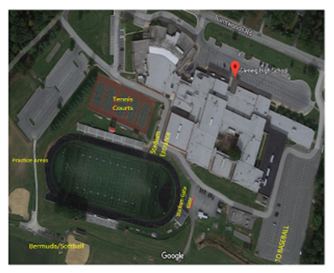
Glenelg High School

Emergency Action Procedures

Gymnasium and Indoor Facilities
Activate the EAP:
- Any loss of consciousness
- Possible Spine Injury
- Dislocation, Open Fracture, Displaced Closed Fracture
- Difficulty or absent breathing or pulse
- Uncertainty of if you have a medical emergency
Emergency Personnel:
Glenelg High School Athletic Trainer will be on site for select practices and events or in direct communication with coaching staff, if available. Emergencies during practices/games not covered, EMS should be contacted immediately.

Emergency Procedures:
- Check the scene
  - Is it safe for you to help?
  - What happened?
  - How many victims are there?
  - Can bystanders help?
- Instruct coach or bystander to call 911
-Provide the following information
- Who you are
- General information about the injury or situation
- Where you are (Provide: name, location of downed athlete, address, telephone #, number of individuals injured, type of injury that has occurred, treatment given, specific directions*). 14025 Burntwoods Rd. Glenelg, MD 21737.
- Specific directions to the game site from nearest major intersection: From 97, turn onto McKendree road at the intersection. Turn right onto Hobbs road. At the stop sign, turn left on to Burntwoods Road. Go straight through the circle (2nd exit) and then turn right into Glenelg High School.
- Any additional information
- *STAY ON THE PHONE, BE THE LAST TO HANG UP*
- Perform emergency CPR/First Aid
  - Check airway/breathing/circulation, level of consciousness, and severe bleeding.
    - If athletic trainer is present he/she will stay with athlete and provide immediate care.
    - If athletic trainer is not present, most qualified coach (training/certifications) will stay with athlete and provide immediate care.
  - Instruct coach or bystander to GET AED!!
- Designate coach or bystander to control crowd
- Contact the Athletic Trainer for Glenelg High School if not present on scene
- Designated coach or appropriate bystander will meet ambulance and direct to appropriate site
  - Open Appropriate Gates/Doors
  - Designate an individual to "flag down" and direct to scene
  - Control injury site, limit care providers etc.
- Assist AT and/or EMS with care as directed
  - Retrieve Necessary Supplies/Equipment
- An assistant coach must go with the athlete to the hospital or follow in a car if there is no parent to accompany athlete.
- Document event and debrief

Glenelg High School
Emergency Action Plan

Stadium and Tennis Courts
14025 Burntwoods Road Glenelg, MD 21737
Activate the EAP:
- Any loss of consciousness
- Possible Spine Injury
- Dislocation, Open Fracture, Displaced Closed Fracture
- Difficulty or absent breathing or pulse
- Uncertainty of if you have a medical emergency
Emergency Personnel:
Glenelg High School Athletic Trainer will be on site for select practices and events or in direct communication with coaching staff. Emergencies during practices/games not covered, EMS should be contacted immediately.

Emergency Procedures:
- Check the scene
  - Is it safe for you to help?
  - What happened?
  - How many victims are there?
  - Can bystanders help?
- Instruct coach or bystander to call 911
-Provide the following information
- Who you are
- General information about the injury or situation
- Where you are (Provide: name, location of downed athlete, address, telephone #, number of individuals injured, type of injury that has occurred, treatment given, specific directions*). 14025 Burntwoods Road, Glenelg MD 21737. Instruct EMS to enter through the gates by the concession stand. Assign a coach or appropriate designee to meet the ambulance.
- Any additional information
- *STAY ON THE PHONE, BE THE LAST TO HANG UP*
- Perform emergency CPR/First Aid
  - Check airway/breathing/circulation, level of consciousness, and severe bleeding.
    - If athletic trainer is present he/she will stay with athlete and provide immediate care.
    - If athletic trainer is not present, most qualified coach (training/certifications) will stay with athlete and provide immediate care.
  - Instruct coach or bystander to GET AED!!
- Designate coach or bystander to control crowd
- Contact the Athletic Trainer for Glenelg High School if not present on scene
- Meet ambulance and direct to appropriate site
  - Open Appropriate Gates/Doors
  - Designate an individual to "flag down" and direct to scene
  - Control injury site, limit care providers etc.
- Assist AT and/or EMS with care as directed
  - Retrieve Necessary Supplies/Equipment
- An assistant coach must go with the athlete to the hospital or follow in a car if there is no parent on scene
- Document event and debrief

Glenelg High School
Emergency Action Plan

Baseball Stadium
14025 Burntwoods Road Glenelg, MD 21737
Activate the EAP:
- Any loss of consciousness
- Possible Spine Injury
- Dislocation, Open Fracture, Displaced Closed Fracture
- Difficulty or absent breathing or pulse
- Uncertainty of if you have a medical emergency
Emergency Personnel:
Glenelg High School Athletic Trainer will be on site for select practices and events or in direct communication with coaching staff. Emergencies during practices/games not covered, EMS should be contacted immediately.

Emergency Procedures:
- Check the scene
  - Is it safe for you to help?
  - What happened?
  - How many victims are there?
  - Can bystanders help?
- Instruct coach or bystander to call 911
-Provide the following information
- Who you are
- General information about the injury or situation
- Where you are (Provide: name, location of downed athlete, address, telephone #, number of individuals injured, type of injury that has occurred, treatment given, specific directions*). 14025 Burntwoods Road, Glenelg MD 21737. Instruct EMS to enter through the second entrance when traveling west on Burntwoods Road. Assign a coach or appropriate designee to meet the ambulance.
- Any additional information
- *STAY ON THE PHONE, BE THE LAST TO HANG UP*
- Perform emergency CPR/First Aid
  - Check airway/breathing/circulation, level of consciousness, and severe bleeding.
    - If athletic trainer is present he/she will stay with athlete and provide immediate care.
    - If athletic trainer is not present, most qualified coach (training/certifications) will stay with athlete and provide immediate care.
  - Instruct coach or bystander to GET AED!!
- Designate coach or bystander to control crowd
- Contact the Athletic Trainer for Glenelg High School if not present on scene
- Meet ambulance and direct to appropriate site
  - Open Appropriate Gates/Doors
  - Designate an individual to "flag down" and direct to scene
  - Control injury site, limit care providers etc.
- Assist AT and/or EMS with care as directed
  - Retrieve Necessary Supplies/Equipment
- An assistant coach must go with the athlete to the hospital or follow in a car if there is no parent on scene
- Document event and debrief

Glenelg High School
Emergency Action Plan

Softball Stadium and Track and Field Practice Areas
14025 Burntwoods Road Glenelg, MD 21737
Activate the EAP:
- Any loss of consciousness
- Possible Spine Injury
- Dislocation, Open Fracture, Displaced Closed Fracture
- Difficulty or absent breathing or pulse
- Uncertainty of if you have a medical emergency
Emergency Personnel:
Glenelg High School Athletic Trainer will be on site for select practices and events or in direct communication with coaching staff. Emergencies during practices/games not covered, EMS should be contacted immediately.

Emergency Procedures:
- Check the scene
  - Is it safe for you to help?
  - What happened?
  - How many victims are there?
  - Can bystanders help?
- Instruct coach or bystander to call 911
-Provide the following information
- Who you are
- General information about the injury or situation
- Where you are (Provide: name, location of downed athlete, address, telephone #, number of individuals injured, type of injury that has occurred, treatment given, specific directions*). 14025 Burntwoods Road, Glenelg MD 21737. Instruct EMS to enter through the second entrance to the school when traveling west on Burntwoods Road. Have EMS continue to the gravel lot to enter through the gates by the outside containers. Assign a coach or appropriate designee to meet the ambulance.
- Any additional information
- *STAY ON THE PHONE, BE THE LAST TO HANG UP*
- Perform emergency CPR/First Aid
  - Check airway/breathing/circulation, level of consciousness, and severe bleeding.
    - If athletic trainer is present he/she will stay with athlete and provide immediate care.
    - If athletic trainer is not present, most qualified coach (training/certifications) will stay with athlete and provide immediate care.
  - Instruct coach or bystander to GET AED!!
- Designate coach or bystander to control crowd
- Contact the Athletic Trainer for Glenelg High School if not present on scene
- Meet ambulance and direct to appropriate site
  - Open Appropriate Gates/Doors
  - Designate an individual to "flag down" and direct to scene
  - Control injury site, limit care providers etc.
- Assist AT and/or EMS with care as directed
  - Retrieve Necessary Supplies/Equipment
- An assistant coach must go with the athlete to the hospital or follow in a car if there is no parent on scene
- Document event and debrief

Glenelg High School
Emergency Action Plan

Bermuda Practice Field
14025 Burntwoods Road Glenelg, MD 21737
Activate the EAP:
- Any loss of consciousness
- Possible Spine Injury
- Dislocation, Open Fracture, Displaced Closed Fracture
- Difficulty or absent breathing or pulse
- Uncertainty of if you have a medical emergency
Emergency Personnel:
Glenelg High School Athletic Trainer will be on site for select practices and events or in direct communication with coaching staff. Emergencies during practices/games not covered, EMS should be contacted immediately.

Emergency Procedures:
- Check the scene
  - Is it safe for you to help?
  - What happened?
  - How many victims are there?
  - Can bystanders help?
- Instruct coach or bystander to call 911
-Provide the following information
- Who you are
- General information about the injury or situation
- Where you are (Provide: name, location of downed athlete, address, telephone #, number of individuals injured, type of injury that has occurred, treatment given, specific directions*). 14025 Burntwoods Road, Glenelg MD 21737. Instruct EMS to enter Sharp Road after the traffic circle. Make the first left into the parking lot. Make the first right into the adjacent parking lot. Assign a coach or appropriate designee to meet the ambulance.
- Any additional information
- *STAY ON THE PHONE, BE THE LAST TO HANG UP*
- Perform emergency CPR/First Aid
  - Check airway/breathing/circulation, level of consciousness, and severe bleeding.
    - If athletic trainer is present he/she will stay with athlete and provide immediate care.
    - If athletic trainer is not present, most qualified coach (training/certifications) will stay with athlete and provide immediate care.
  - Instruct coach or bystander to GET AED!!
- Designate coach or bystander to control crowd
- Contact the Athletic Trainer for Glenelg High School if not present on scene
- Meet ambulance and direct to appropriate site
  - Open Appropriate Gates/Doors
  - Designate an individual to "flag down" and direct to scene
  - Control injury site, limit care providers etc.
- Assist AT and/or EMS with care as directed
  - Retrieve Necessary Supplies/Equipment
- An assistant coach must go with the athlete to the hospital or follow in a car if there is no parent on scene
- Document event and debrief

Glenelg High School
Emergency Action Plan

Football and Lacrosse Practice Field
14025 Burntwoods Road Glenelg, MD 21737
Activate the EAP:
- Any loss of consciousness
- Possible Spine Injury
- Dislocation, Open Fracture, Displaced Closed Fracture
- Difficulty or absent breathing or pulse
- Uncertainty of if you have a medical emergency
Emergency Personnel:
Glenelg High School Athletic Trainer will be on site for select practices and events or in direct communication with coaching staff. Emergencies during practices/games not covered, EMS should be contacted immediately.

Emergency Procedures:
- Check the scene
  - Is it safe for you to help?
  - What happened?
  - How many victims are there?
  - Can bystanders help?
- Instruct coach or bystander to call 911
-Provide the following information
- Who you are
- General information about the injury or situation
- Where you are (Provide: name, location of downed athlete, address, telephone #, number of individuals injured, type of injury that has occurred, treatment given, specific directions*). 14025 Burntwoods Road, Glenelg MD 21737. Instruct EMS to enter Sharp Road after the traffic circle. Make the first left into the parking lot. Make the first right into the adjacent parking lot. Assign a coach or appropriate designee to meet the ambulance.
- Any additional information
- *STAY ON THE PHONE, BE THE LAST TO HANG UP*
- Perform emergency CPR/First Aid
  - Check airway/breathing/circulation, level of consciousness, and severe bleeding.
    - If athletic trainer is present he/she will stay with athlete and provide immediate care.
    - If athletic trainer is not present, most qualified coach (training/certifications) will stay with athlete and provide immediate care.
  - Instruct coach or bystander to GET AED!!
- Designate coach or bystander to control crowd
- Contact the Athletic Trainer for Glenelg High School if not present on scene
- Meet ambulance and direct to appropriate site
  - Open Appropriate Gates/Doors
  - Designate an individual to "flag down" and direct to scene
  - Control injury site, limit care providers etc.
- Assist AT and/or EMS with care as directed
  - Retrieve Necessary Supplies/Equipment
- An assistant coach must go with the athlete to the hospital or follow in a car if there is no parent on scene
- Document event and debrief

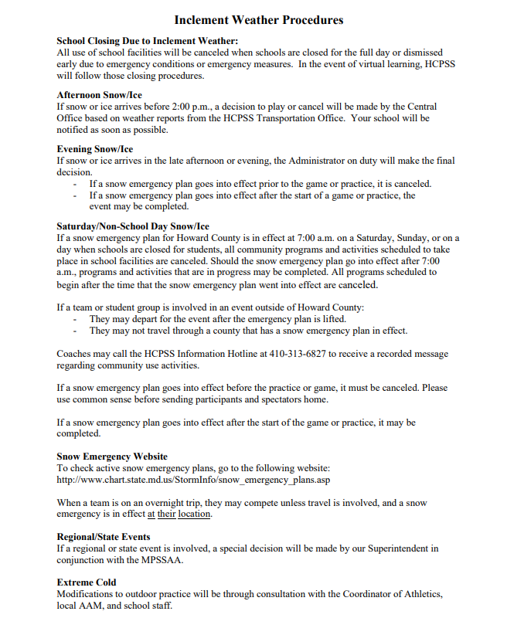

Heat Acclimation Policy and Guidelines based on HCPSS Student Athlete Handbook

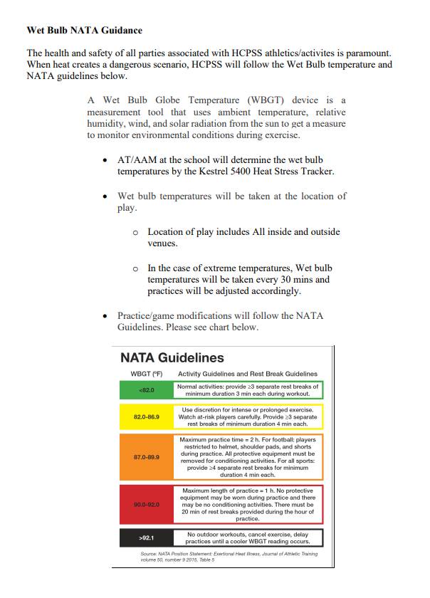
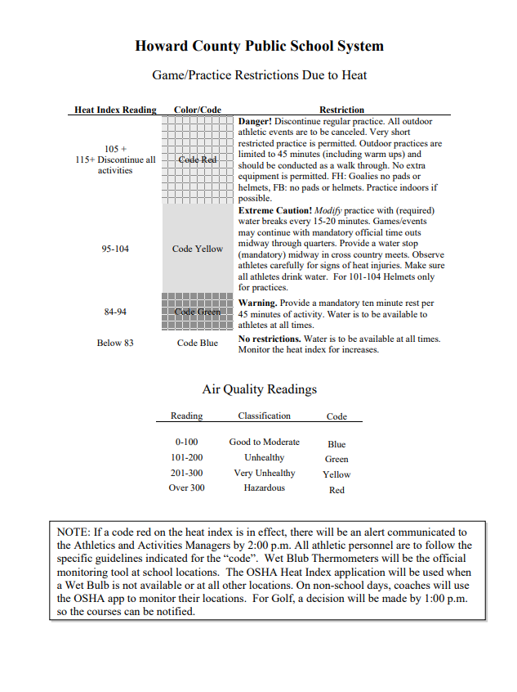

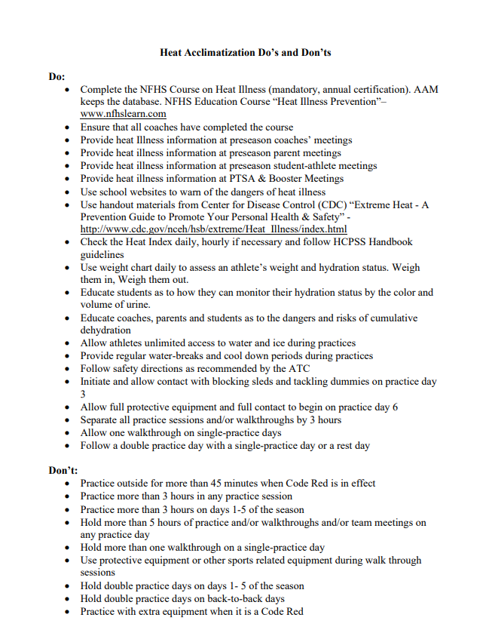

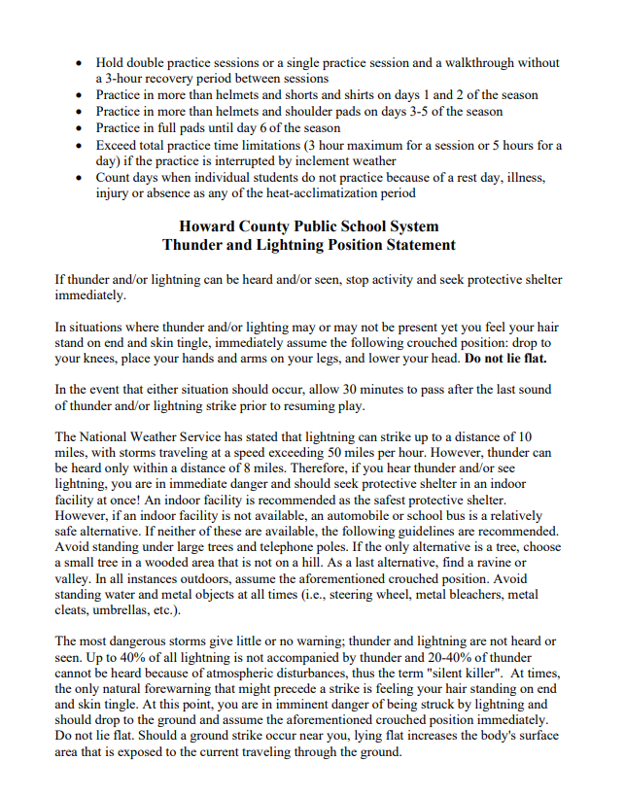

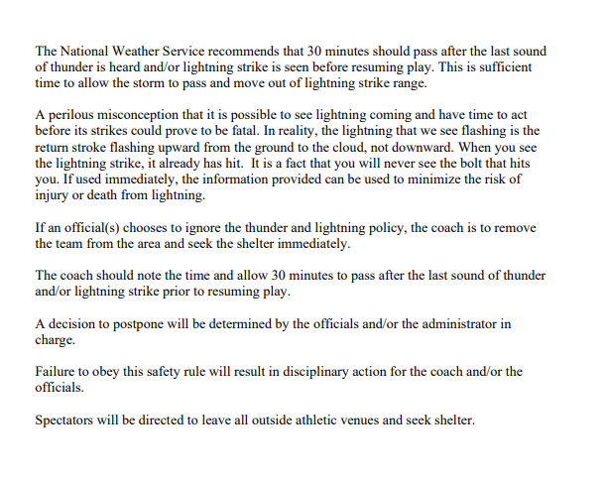

Care of Emergent Injuries in Athletics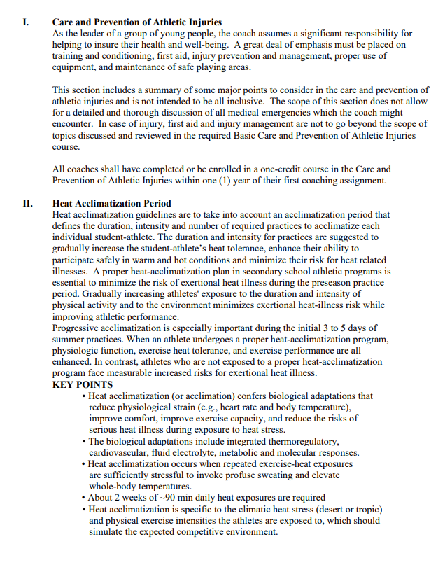

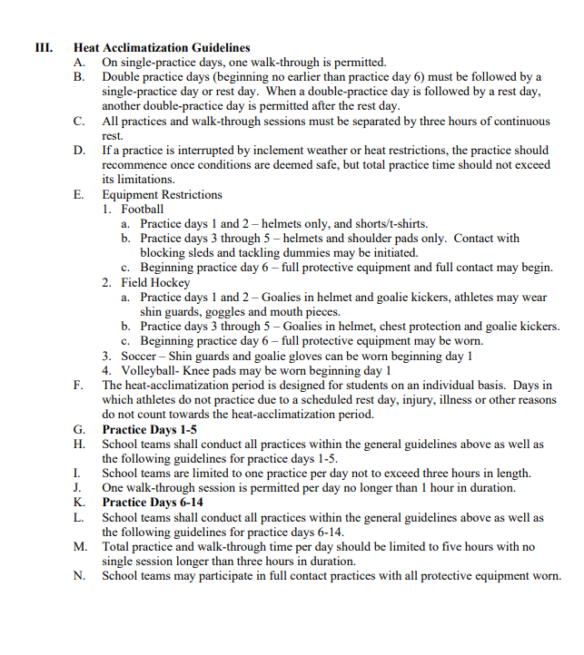

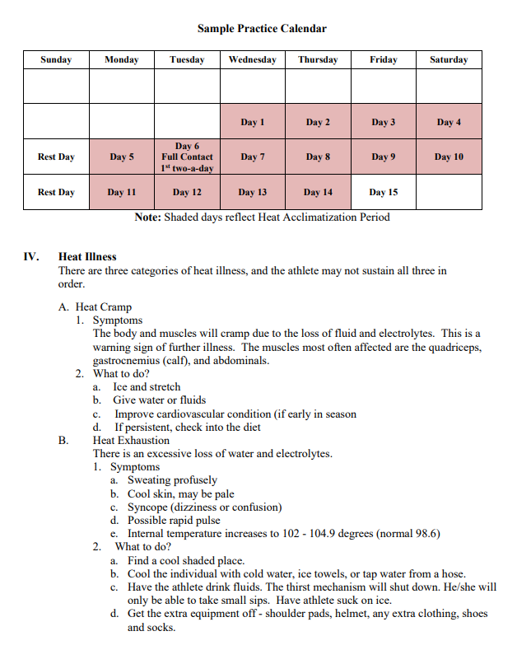

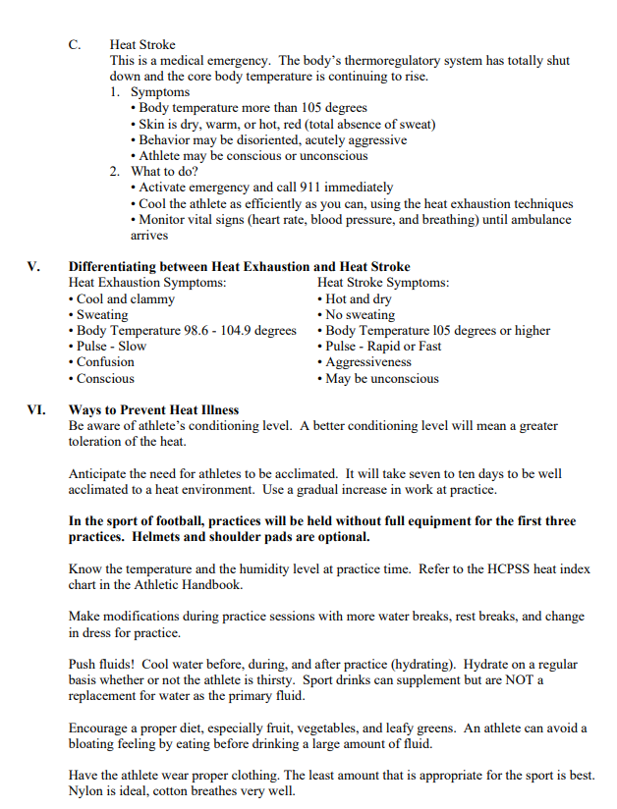

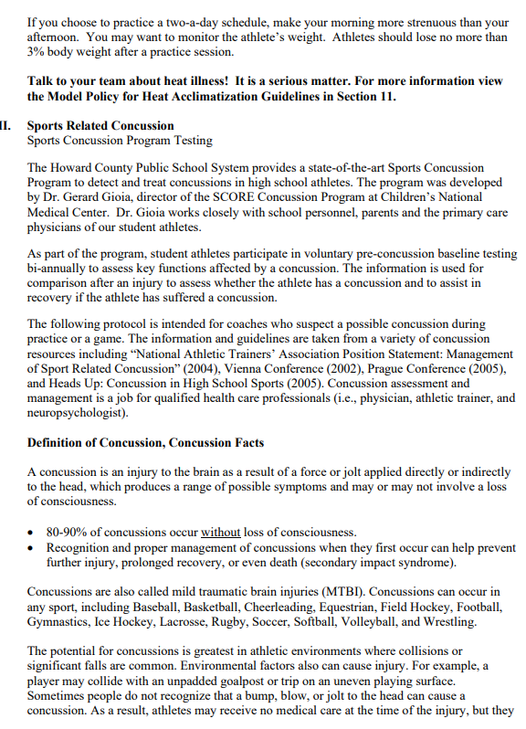

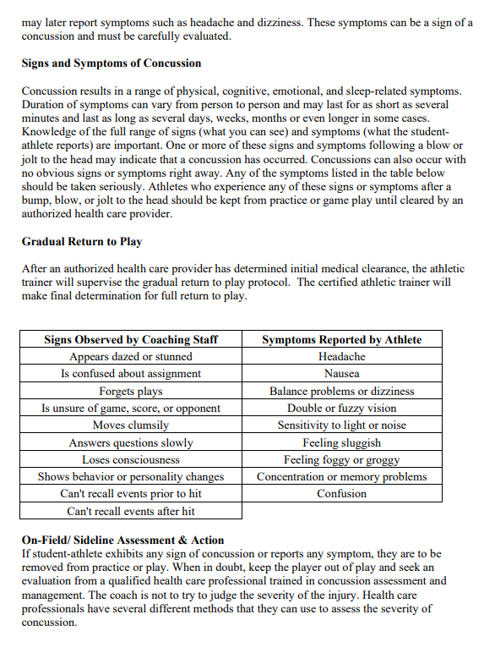

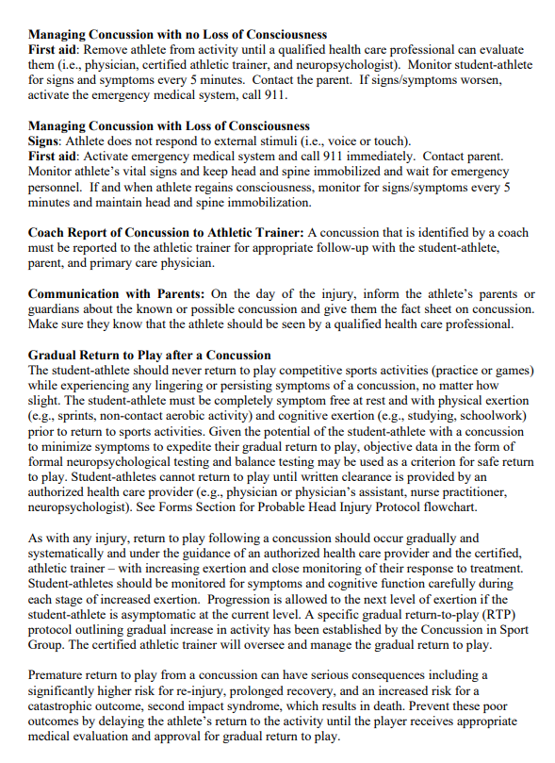

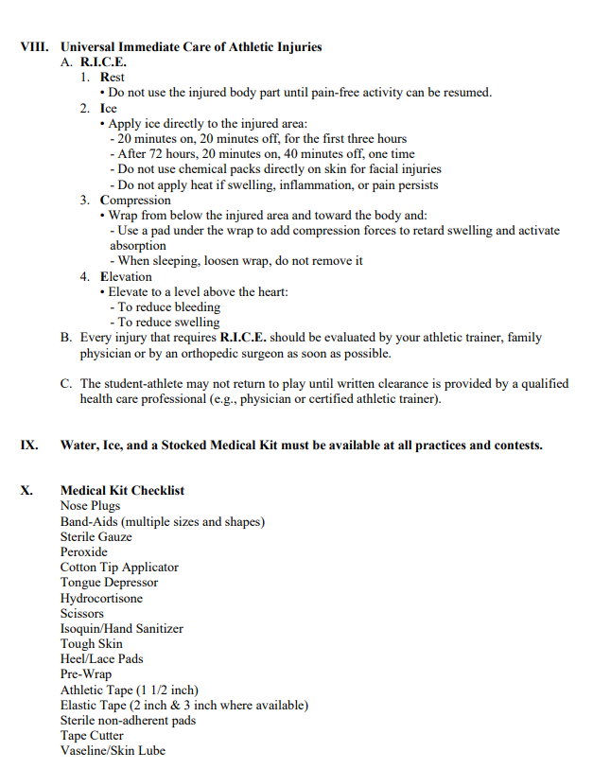

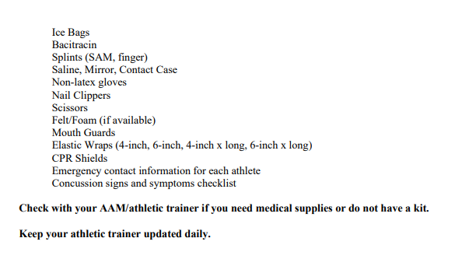

Automatic Defibrillator Use

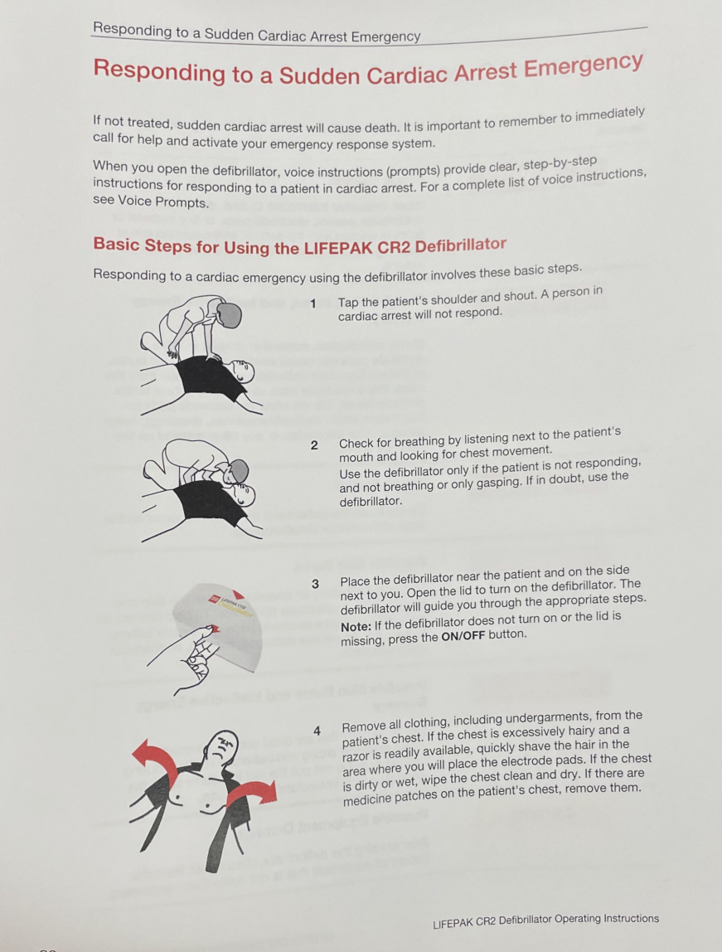

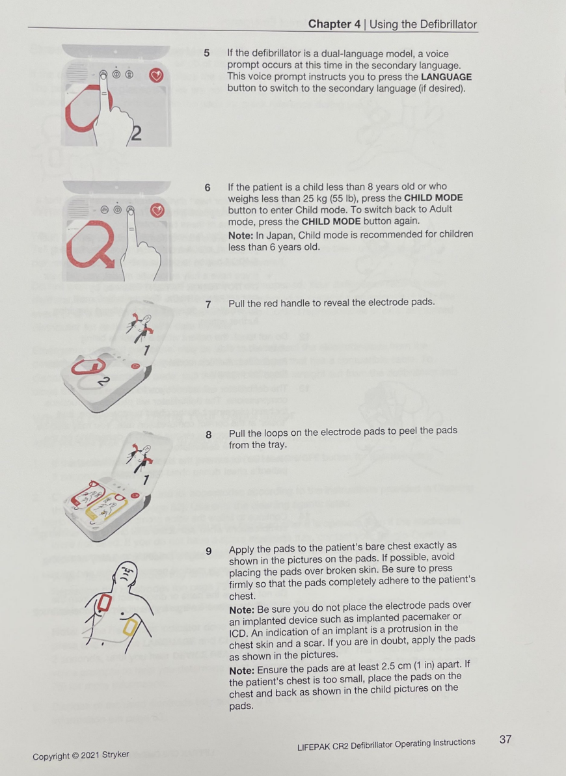

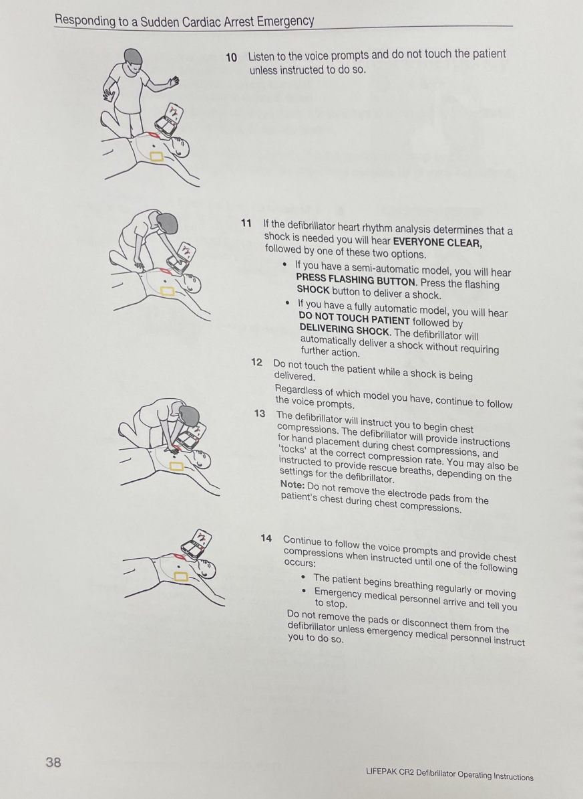

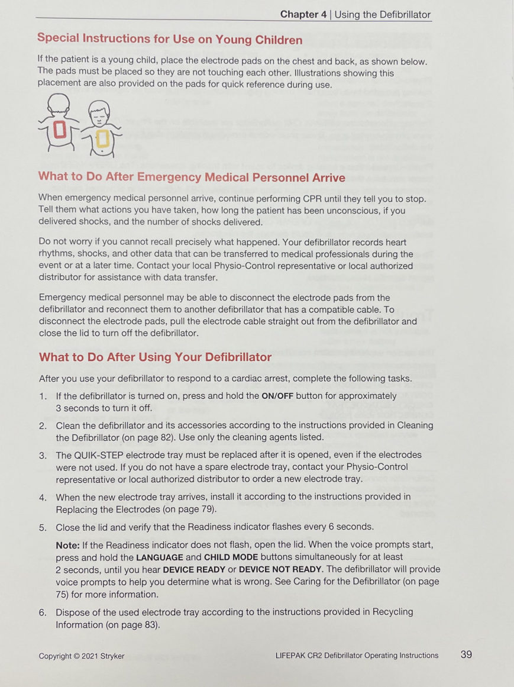

Rehearsal Strategy

The athletic trainer will be responsible for reviewing the EAP annually and rehearsing it prior to each sport season.
Coaches at Glenelg High School will be educated on the EAP prior to their first season of coaching during each academic year. The meeting will be a requirement for all coaches, of all levels, of each sport.
The meeting will be directed by the athletic trainer and will include a presentation for recent updates along with a hands-on portion. The hands-on portion will run through different scenarios to ensure the coaches understand the EAP. All coaches will be provided the opportunity to ask any and all questions and the athletic trainer will be responsible for ensuring a proper and adequate answer to all questions.
All coaches must sign in to prove their attendance, see following page. The documentation of attendance will be stored with the athletic trainer.

Documentation of Seasonal Coaches Educational Meeting
Topic: EAP Rehearsal
Sign in Sheet
Coach Name (printed) | Sport | HS | MS | Signature
Notes:

Approval and Verification Page:
This document has been read and revised by the Glenelg High School athletic trainer, team physician and athletic director.
Athletic Trainer: ______________________________________ Date: ______________
Athletic and Activities Manager: _____________________________________ Date:______________

